Analysis of Two Companies Under Armour and Hanes brand Using Company Annual Reports
Name
Institution

Abstract
The report analyzes and compares financial reports for the companies Under Armor and Hanesbrand. It is aimed at advising any potential investor on the best company they should put their hard earned money. To aid the analysis annual reports of both companies will be utilized with an emphasis made on the financial statements produced by the two companies for the last 5 years. For an investor to be convinced of a company’s viability they should be able to have a quantifiable and verifiable information about the same. For this reason the paper will identify risks, material information from financial statement notes and take a close look on intangible assets such as the goodwill to identify any potential information that would make a company suitable/unsuitable for one to invest.

Introduction
Under Armour and Hanesbrand are two American sports equipment companies. They specialize in manufacturing sports and casual apparel as well as footwear. The two companies are publicly traded and their current share price is $18.29 for the Hanesbrands and $22.87 for the Under Armour Inc. Their current share price depict that they have a potential to grow and reach to levels of blue chip companies if they take on the opportunities and minimize the threats that are in the sports equipment industry. In deciding which company to invest in due to limited resources and the need to maximize returns, one would need to consider more than the current share price that the shares of both companies are trading (Penman, 2019). To aid in summarizing the right company to invest in a comparison of the financial statement for the last 5 years will be conducted. In these financial years, the financial statements will be scrutinized to reveal information on the ROI performance for each company. Also, various financial ratios will be calculated to fish out the company that is doing better and that promises a future growth in a shareholder’s investment.
Each company’s financial statements (Income statement, Balance sheet, Cash flow, Stockholders’ Equity)
- Balance sheet
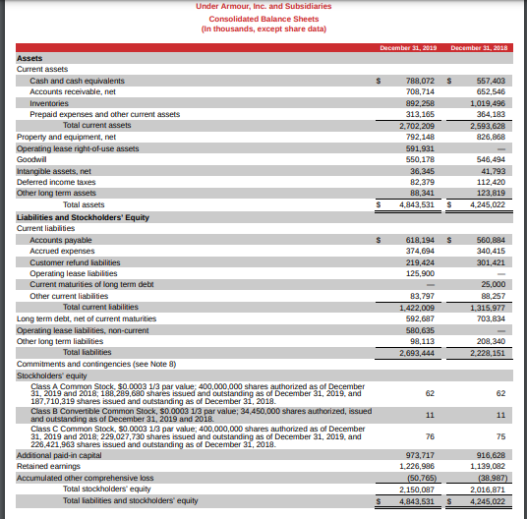
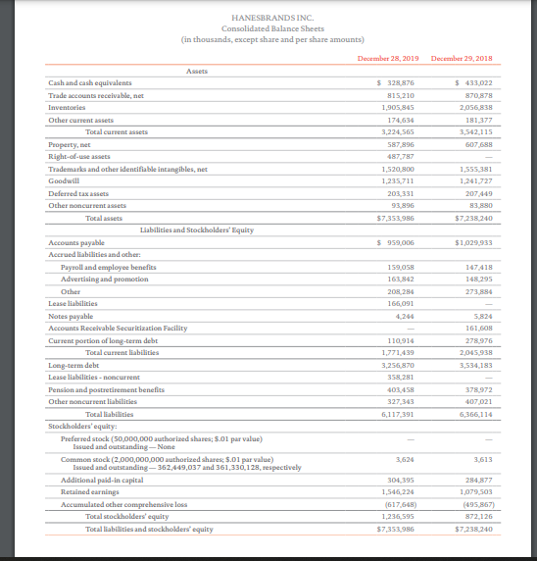
A close look of the two companies balance sheet there are a number of issues that an investor would be interested to know. The issues include the liability of each company, assets and the shareholders equity. In 2019, Hanesbrand Inc. had total assets of $7,353,986, the liability was at record $6,117,391 down from $6, 366,114 previous year. The owners’ equity for the company was $1,236,595. One can conclude that as far as the balance sheet is concerned the company is more debt financed. This implies that most of its profits are deducted to pay for interests and principal amounts outstanding to finance the activities of the company. On the other hand, Under Armour recorded total assets at $4,843,531, the liabilities were at a record high of $ 2, 693,444 as at the close of the 2019 financial year. The total stockholders’ equity was $2,150,087. A close look at the finance element of the company shows that there is an equal use of the debt and equity finance. It indicates that profitability is well distributed and stockholders realize a good value of their investment as much is not lost through financing debt instruments.
(Balance sheet for the previous years are included in the appendix section)
- Income Statement
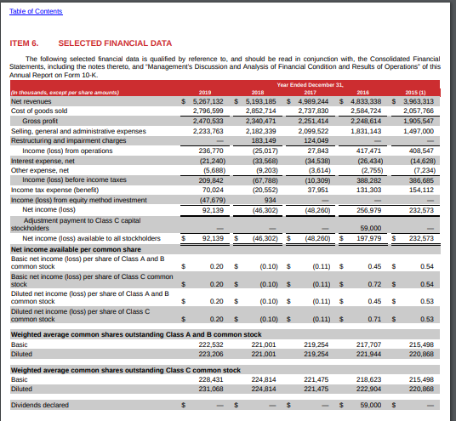

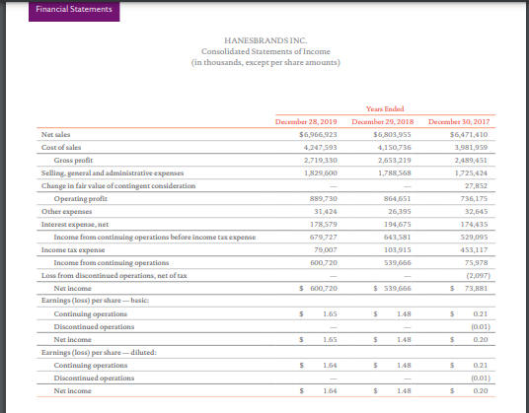
Looking the trend of profitability for the two companies shows an increasing trend. Unlike for Under Amour that had a deep in the profits it realized the two companies show a promising future aspect of increasing profitability. Their expenses are increasing as we move over the others implying that efficiency will be a key determinant of the success of each company.
- Statement of cash flow
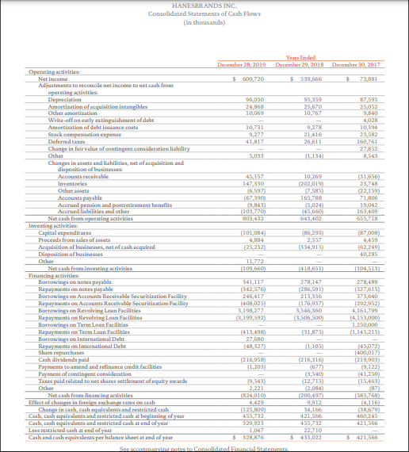
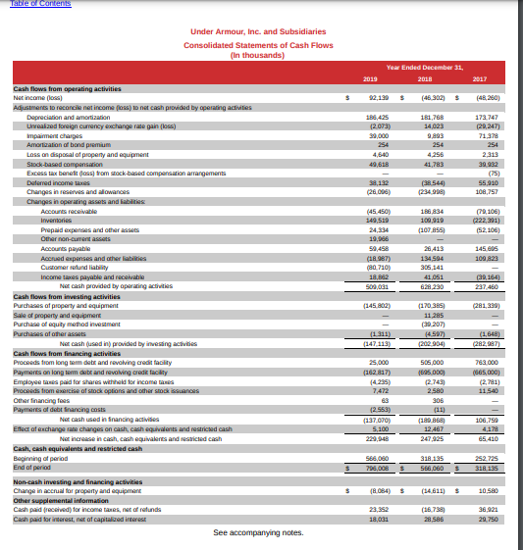
Cash is ‘King’ and for any business to run there should be enough of it to cater for its current need of the item. The two companies have a strong reservation for the item and show a positive figure as far as they are concerned. Even though most of the cash is used to finance the operating activities not much of it is used in financing which shows that the two companies are strategic in the manner in which they seek extra money to finance their activities. Also, the cash from operating activities is more than the net income generated by both companies which a strong indicator that the quality of earning is good.
- Statement of Owners’ Equity
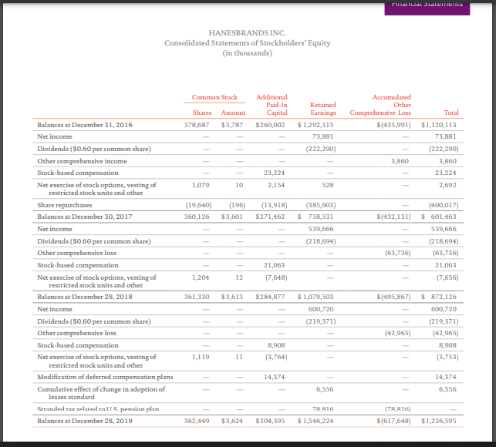
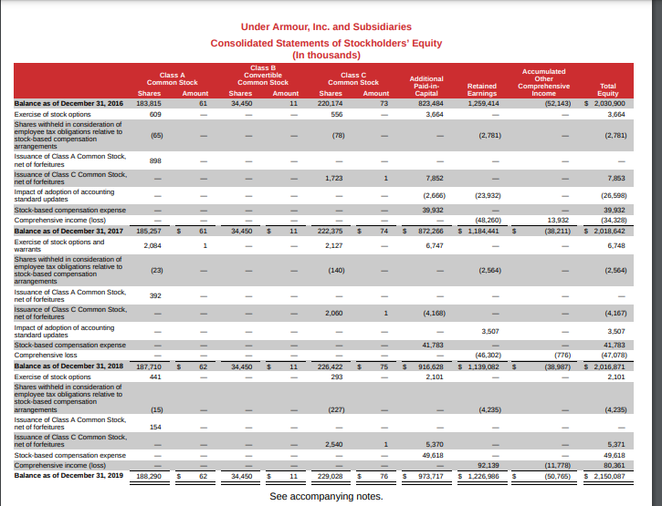
There is a notable difference of the two companies when it comes to the owners’ equity statement of the two companies. While the shares of HanesBrand trade as ordinary shares those of Under Amour have two different classes (Penman, 2019). There is a class A and class C. The class A shares as described on the Company’s Investor Relations website are traded under the symbol, UAA and those of C, traded under the symbol UA. The company has not rolled out any dividend share as it is the case with the Hanesbrands. It has however, seen an increase in owners capital by posting increasing retained earnings across the years. As far as the Owners’ Equity statement is concerned the Hanesbrand has a better position as far as dividends and increase of shareholders value is concerned. Throughout the years the company has declared and paid out dividends to the shareholders.
The identified risks addressed in the annual reports
The two companies have stated a long list of the risk factors that they face. For Under Amour, the first five listed risks include fear that during economy downturn consumers’ purchasing power is highly affected and it ends up hurting their sales. Secondly, any financial negativity that would affect their wholesale clients their sales would be greatly affected since they depend mostly on them. There is a risk by Under Amour to fail to implement their long-term strategies which will consequently affect their operations. Remarkably, the company fears that it may not realize the benefits of their restructuring plan that costed them a lot of money. There is a material risk by the company that their business results could be affected by natural calamities such as extreme weather conditions, pandemics and political crisis (Penman, 2018). Similarly, Hanesbrand faces such risks the difference lies on the ones they prioritize. For the company, they fear that competition is negatively affecting their sales due to diminishing market share. The company as well knows that rapidly changing environment will likely affect their business results and their financial conditions negatively if it continues to change rapidly. Failure in information technology as well as any breach in security is a material risk that Hanesbrand fears. A probable occurrence would affect the business operations and worsen its financial condition. Also, loss of senior manager or any other key personnel would dump the business operations down since the company’s business depends on them. Lastly, failure to properly manage the strategic projects launched will ruin the business prospects of the company. ` `
The Management Discussion & Analysis (MD&A) section
For both companies there is a holistic overview of the companies and detailed analysis of the results and failures they have faced in the MD&A section. For an investor point of view however, which is the sole purpose of writing the paper, one would be interested by the strategies section given by each company. Notably, the other information is material such as the segment performance, tax expenses comment on business trends but the strategic one gives an oversight of the moves the company will take to move forward. For Hanesbrand, the management states that it will adopt an ‘Innovate-to-Elevate strategy. The strategy is aimed at integrating their superior and leading brand to their clients while reducing the costs thereof. They propose a more consumer focused brand that will see it stand out for the next 5 to 10 years. They will attain this by ensuring that the innovation and emerging trends are well integrated to suit the needs of the customers (Penman, 2020). Lastly, the management proposes on focusing on the low-cost global supply that will see them reduce the costs of production and supply significantly. As far as Under Amour is concerned, they have restructuring process that commenced in 2020. The company seeks to rebalance the costs and improve profitability. The company has set out a budget of $425 million to adopt the restructuring plan. Previous restructuring plans that were conducted during the year 2017 and 2018 have seen the company improve its sales and decrease the cost base effectively. Such moves by the company show that it has good business prospects in the future.
The notes to the financial statements addressed in the annual reports
The notes to financial statements disclose any material information that concerns the items under financial statements. Any assumptions that were used to arrive at the figures. For the two companies there were no special items that were identified (Penman, 2018). Additionally, for the Hanesbrand there were no changes in and any disagreement with the accountants on financial disclosure. For Under Amour, the company changed some accounting principles. For example, accounting for leases and revenues were altered to make them more ascertainable. Remarkably, the two companies provide a fair an all material respective financial position of the companies.
Balance sheet with particular focus on Goodwill/Intangible Assets
In the most current fiscal year Under Amour contacted a goodwill impairment assessment. The balance of the Goodwill was $550.2 million. It is the company’s responsibility of the company to conduct annual impairment to ascertain the fair value of the item. Notably, the goodwill of the Under Amour Company reflects the value of the products it offers to the consumers as it forms a big part pf the assets the company recorded over the years. It is also worth noting that the fair value has constantly increased over the years. On the other hand, Hanesbrand Goodwill was reported at $1,235,711 down from $1,241,727. On the risk factors section the company had reported that a decline in the fair value of its intangible assets would result to an impairment charge (Penman, 2019). The drop of the goodwill fair value reported is well explained by the materialization of the risk. It shows that the company’s Goodwill varies from time to time depending on the prevailing market conditions. Remarkably, the impairment charge that occurs from time to time would greatly affect the earnings per share an investor would get in each particular fiscal year.
External auditor’s assessment re. The quality of the company’s financial accounting/reporting
As par the form-10k, the financial reporting of both companies have sufficient information and there are no significant issues that could warranty any further scrutiny. The accounting policies and standards recommended for public companies are well followed with subsequent assumptions well specified on the financial statement notes section. The financial statements provided are therefore, suitable for use by any stakeholder for purposes of investing, investigating and knowledge acquisition.
Any other sections of the annual report that you believe are relevant to your analysis
According to my opinion, there is no other relevant section of the annual report is needed for analysis. More information will be provided on the ratio analysis section and it will be sufficient for one to give recommendations about the best company to invest.
RATIO ANALYSIS
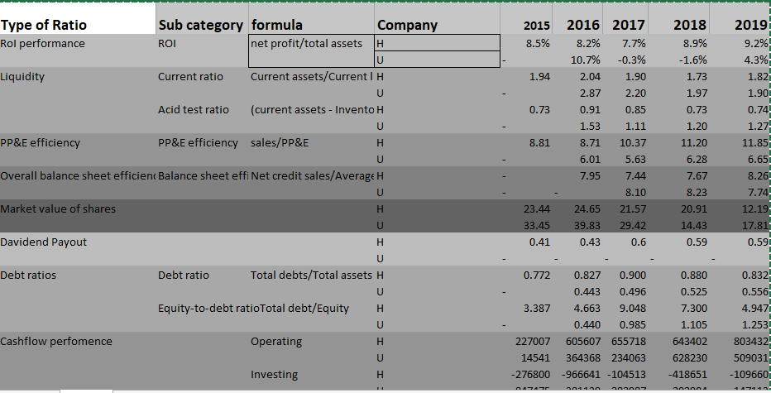
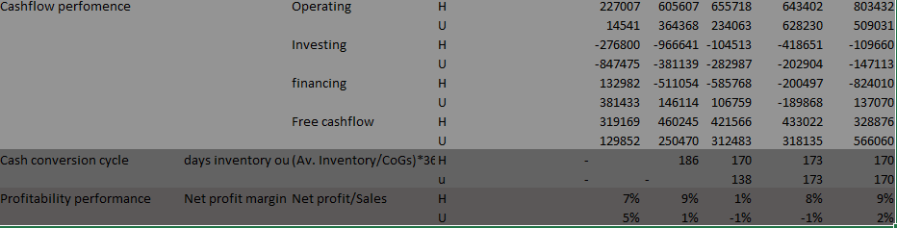
From the various ratios analyzed there is sufficient information for an investor to choose the company to invest. Over the last 5 years Hanesbrand had a better ROI. Remarkably, Under Armour had better liquidity over the last 5 years and was capable of settling current liabilities that arose. Hanesbrand has a better PP&E efficiency meaning that the company has put a good use of the PP&E that it has purchased over the last 5 years (Penman, 2020). Under Armour is yet to roll out dividends to its shareholders making Hanesbrand company a better investment option for an investor who is looking for a payout from his investment. Under Armour however, had a better market share price compared to its competitor whereas the overall balance sheet efficiency was better for the competitor. Hanesbrand is more debt financed and its gearing ratio is bad compared to that of Under Amour. Cash conversion cycle is same for both companies over the 5 years but Hanesbrand is more profitable than Under Armour.
Recommendations
From the calculations of various ratios and a look of the financial statements of both companies. It is advisable for an investor to invest in the Hanesbrand. Notably, if such investor is looking for a long term growth of his capital Under Armour is best suited for such option.

References
Penman, S. T. E. P. H. E. N. H. (2020). Financial statement analysis and security valuation. Place of publication not identified: MCGRAW-HILL.
Penman, S. H. (2018). Financial statement analysis and security valuation. New York: McGraw-Hill.
Penman, S. (2019). Financial Statement Analysis and Security Valuation. London: McGraw-Hill Publishing.

